Group No …..

**Project Management Plan**

**Travel Management System**

|  |  |
| --- | --- |
| **Name** | **ID** |
| Sabiha Rahman | **20-41944-1** |

**Date : 27-08-2023**

Table of Contents

**Introduction …………………………………………………………………………………………….. 2**

**Project Management Approach…………………………………………………………………………2**

**Project Title ………………………………………………………………………………………………3**

**Justification ………………………………………………………………………………………………3**

**Objective And project Scopes……………………………………………………………………………3**

**Overview Of the project …………………………………………………………………………………4**

**Stakeholders Analysis……………………………………………………………………………………5**

**Milestone List ……………………………………………………………………………………………5**

**Process Model to be followed……………………………………………………………………………6**

**Work Breakdown structure …………………………………………………………………………….7**

**Estimation ………………………………………………………………………………………………..8**

**Resource Requirements …………………………………………………………………………………9**

**Software Requirement ……………………………………………………………………………9**

**Hardware Requirement …………………………………………………………………………..9**

**Human Resource Requirement …………………………………………………………………..9**

**Project Schedule ……………………………………………………………………………………….10**

**Delivery Plan……………………………………………………………………………………………..10**

**Risk Analysis……………………………………………………………………………………………11**

**Quality Control Plan ……………………………………………………………………………………11**

**Budget ……………………………………………………………………………………………………11**

**Conclusion…………………………………………………………………………………………………12**

# Introduction:

SHEBA is a software platform or application that helps individuals and organizations efficiently manage various aspects of travel planning and execution. It serves as a centralized tool to streamline the entire travel process, including trip booking, itinerary management, expense tracking, and reporting.

The primary goal of a travel management system is to simplify and automate travel-related tasks, saving time and effort for both travelers and travel administrators. It provides users with a user-friendly interface to search and book flights, hotels, car rentals, and other travel services, often integrating with third-party travel suppliers and aggregators to offer a wide range of options.

# PROJECT MANAGEMENT APPROACH

Waterfall Approach: In a Waterfall approach, the project is divided into sequential phases. For a travel management system, these phases could include requirements gathering, system design, development, testing, deployment, and maintenance. This approach is suitable when the requirements are well-defined upfront and changes are minimal.

Agile Approach: An Agile approach, such as Scrum or Kanban, is well-suited for projects with evolving requirements and a need for frequent feedback. The development of the travel management system could be divided into iterative sprints, each delivering a functional increment. Stakeholder feedback is incorporated at the end of each sprint to ensure alignment with changing needs.

**PROJECT TITLE: SHEBA Travel Management System**

**JUSTIFICATION**: Efficiency and Time Savings: Sheba Travel Management streamlines the entire travel process, from planning to booking and expense management. By providing a centralized platform, it eliminates the need for manual tasks and reduces administrative overhead. This increases efficiency, saves time, and allows employees to focus on more strategic activities.

Cost Savings: Sheba Travel Management helps organizations achieve cost savings in several ways. It provides access to a wide range of travel options, allowing users to compare prices and choose the most cost-effective options. The system also enforces travel policies, ensuring compliance and preventing unnecessary expenses. By analyzing travel expenses through reporting and analytics, organizations can identify cost-saving opportunities and negotiate better rates with vendors.

Enhanced Traveler Experience: Sheba Travel Management prioritizes the traveler experience by providing a user-friendly interface and access to real-time travel information. It offers features like travel alerts, insurance information, and emergency assistance, ensuring the safety and well-being of travelers. By simplifying the travel process and providing support services, the system enhances traveler satisfaction and productivity.

Scalability and Customization: Sheba Travel Management can be tailored to the specific needs of organizations, regardless of their size or industry. The system is scalable and can accommodate the growth and changing requirements of businesses. It can be customized to align with travel policies, preferred suppliers, and reporting needs, ensuring a personalized experience for each organization.

**OBJECTIVES AND PROJECT SCOPES:**

The objectives for a "Sheba Travel Management System" could vary based on the specific needs and goals of the system. However, here are some common objectives that a travel management system might aim to achieve:

Efficient Travel Booking: Streamline the process of booking flights, hotels, transportation, and other travel-related services for employees or clients to reduce time and effort spent on manual booking processes.

Cost Savings: Enable better cost control and optimization of travel expenses through features such as fare comparisons, negotiated rates with vendors, and expense tracking.

Enhanced Visibility: Provide real-time visibility into travel itineraries, bookings, and expenses for both travelers and management, allowing for better decision-making and planning.

Policy Adherence: Enforce travel policies and guidelines automatically within the system to ensure that all travel bookings and arrangements comply with company policies and regulations.

Centralized Data: Create a centralized repository for travel-related information, including travel histories, preferences, and expenses, allowing for more informed decision-making and reporting.

Automation and Integration: Automate repetitive tasks, such as approval workflows, expense reporting, and travel document management. Integration with other systems (e.g., HR, finance) can lead to seamless data flow and reduced manual data entry.

Traveler Experience: Offer a user-friendly interface that empowers travelers to easily book and manage their travel arrangements, leading to a positive experience and increased satisfaction.

Project scope : The scope of Sheba Travel Management System encompasses the entire travel management process for individuals and organizations. It includes various stages such as trip planning, booking, itinerary management, expense tracking, policy enforcement, reporting, and traveler support.

**OVERVIEW OF THE PROJECT:**

Sheba Travel Management is a comprehensive travel management system designed to streamline and simplify the travel processes for individuals and organizations. It offers a user-friendly platform that integrates all aspects of travel management, from trip planning and booking to expense tracking and reporting.

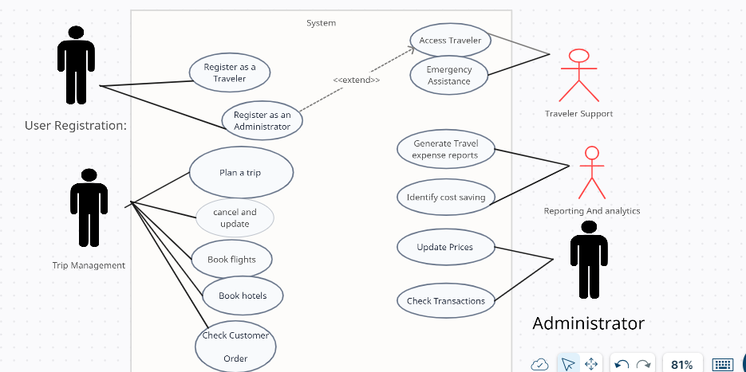

**Use case Diagram of the proposed systems**

**STAKEHODERS ANALYSIS:**

Travelers: Individuals who will use the Sheba Travel Management System to plan, book, and manage their travel itineraries.

Travel Administrators: Employees responsible for managing travel arrangements and policies within the organization.

Finance Department: Personnel involved in expense tracking, reimbursement, and financial reporting related to travel expenses.

IT Department: Professionals responsible for system implementation, maintenance, and technical support.

Senior Management: Decision-makers who oversee travel budgets, policies, and strategic initiatives.

Secondary Stakeholders:

Human Resources Department: May be involved in integrating the travel management system with employee profiles and HR systems.

Compliance and Audit Teams: Responsible for ensuring adherence to travel policies and regulatory requirements.

Travel Suppliers and Aggregators: Companies providing travel services, such as airlines, hotels, car rental agencies, and travel agencies, which integrate with the travel management system.

Travel Insurance Providers: Companies offering travel insurance coverage and services.

Reporting and Analytics Teams: Professionals who utilize the system's data and reports to analyze travel expenses, trends, and patterns for strategic decision-making.

MILESTONE LIST

Project Duration: 8 months (From: September 1, 2023, To: April 30, 2024)

This milestone list outlines the major stages of development for the Travel Management System (TMS). The TMS aims to streamline travel booking, management, and administration for both customers and travel agents. The project timeline spans nine months, from initial planning to full-scale launch, with ongoing maintenance and enhancements post-launch. The milestones are subject to adjustments based on evolving requirements and unforeseen challenges. Regular communication and project monitoring will ensure that any changes to milestones or delivery dates are appropriately managed.

|  |  |  |
| --- | --- | --- |
| Milestone | Description | Date |
| Complete SRS | During this phase, you'll gather and document detailed requirements for the software. This document will serve as a blueprint for the entire project and will guide subsequent development phases. | (September 1,2023) to (15 September 2023) |
| Design | In this phase, you'll translate the requirements into a detailed design that outlines how the software will be structured and how its components will interact with each other. | (September 16,2023) to (26 October 2023) |
| Complete Coding | During this phase, you'll implement the design by writing the actual code for the software, building the functionality as outlined in the SRS and design documents. | (October 27,2023) to ( January 25, 2024) |
| Complete Testing and Debugging | In this phase, you'll thoroughly test the software to identify and fix any bugs, errors, or issues. This phase ensures that the software is stable and operates as expected. | ( January 26 ,2024) to (March 17, 2024) |
| Documents – User Guides and Installation | During this phase, you'll create necessary documentation to guide users in using the software and facilitate its installation. | (March 17, 2024) to (29 April, 2024) |

**Process Model to be followed:**

The agile process model encourages continuous iterations of development and testing. Each iteration is designed to be small and manageable. So, it can be completed within a few weeks. Each iteration is focuses on implementing a small set of features completely. It involves customers in the development process and minimize documentation by using informal communication. 1. Requirements are assumed to be changed. 2. The system evolves over a series of short iterations Documentation is done only when needed.

**WORK BREAKDOWN STRUCTURE:**

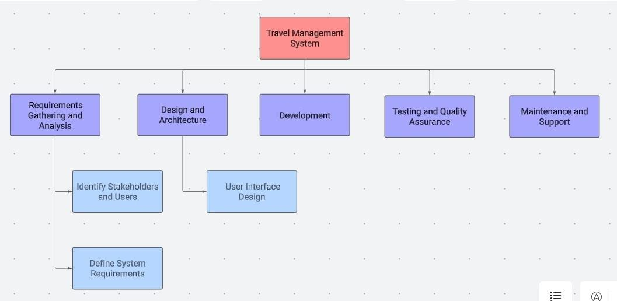

1.1 Requirements Gathering and Analysis

1.1.1 Identify Stakeholders and Users

1.1.2 Define System Requirements

1.1.3 Analyze Existing Processes

1.1.4 Determine Functionalities

1.2 Design and Architecture

1.2.1 System Architecture Design

1.2.2 User Interface Design

1.2.3 Database Design

1.3 Development

1.3.1 Backend Development

1.3.1.1 User Management Module

1.3.1.2 Booking Module

1.3.1.3 Payment Gateway Integration

1.3.2 Frontend Development

1.3.2.1 User Interface Implementation

1.3.2.2 Booking Interface

1.3.3 Integration of Modules

1.4 Testing and Quality Assurance

1.4.1 Unit Testing

1.4.2 Integration Testing

1.4.3 User Acceptance Testing

1.4.4 Bug Fixing and Issue Resolution

1.5 Deployment and Rollout

1.5.1 Preparing Production Environment

1.5.2 Data Migration

1.5.3 System Deployment

1.5.4 User Training and Documentation

1.6 Maintenance and Support

1.6.1 Monitoring and Performance Optimization

1.6.2 Bug Fixes and Updates

1.6.3 User Support and Helpdesk

1.7 Project Management and Coordination

1.7.1 Project Planning and Scheduling

1.7.2 Risk Management

1.7.3 Progress Tracking and Reporting

**ESTIMATION:**

For this project, we are going to use COCOMO to estimate the cost of this project. Suppose, our project is Organic type. The project is estimated to be **20000 SLOC**. Now we have to calculate effort, development time and required number of people.

|  |  |  |  |
| --- | --- | --- | --- |
| **Software Project**  **Type** | **Coefficient**  **<Effort Factor>** | **P** | **T** |
| Organic | 2.4 | 1.05 | 0.38 |
| Semi-detached | 3.0 | 1.12 | 0.35 |
| Embedded | 3.6 | 1.20 | 0.32 |

**PM:** Person-months needed for project

**SLOC:** Source lines of code.

**P:** Project complexity (1.04 -1.24)

**DM:** Duration time in months for project.

**T:** SLOC-dependent coefficient (0.32-0.38)

**ST:** Average staffing necessary. Our project is **Organic** type.

So, Effort = PM = Coefficient <EffortFactor>*(SLOC/1000) ^P

= 2.4*(20000/1000) ^1.05

= 55.75

Development Time = DM = 2.50*(PM) ^T

= 2.50*(55.75) ^0.38

= 11.52

Required Number of People = ST = Effort (PM)/Development Time (DM)

= 55.75/11.52

= 4.83

**RESOURCE REQUIREMENTS**

**SOFTWARE REQUIREMENTS:**

1. Functional Requirements

2. Non-Functional Requirements

3. User Requirements

4. System Requirements

**HARDWARE REQUIREMENTS:**

1.Server Infrastructure

2.Client Devices

3.Network Infrastructure

4.Database Server

**HUMAN RESOURCE REQUIREMENTS**

1.Project Manager

2.Business Analyst

3.Software Developers

4.Quality Assurance

**PROJECT SCHEDULE:**

|  |  |  |  |  |
| --- | --- | --- | --- | --- |
| Serial | Tasks | Start | Duration | Responsibility |
| 1 | Gathering information | 01-09-23 | 15 days | Developer/Tester |
| 2 | Planning | 16-09-23 | 41 days | Testing team lead |
| 3 | Design | 27-10-23 | 90 days | Testing team lead |
| 4 | Code/Test | 26-01-24 | 80 days | Developer/Tester |
| 5 | Review and launch | 17-03-24 | 42 days | Developer/Tester |

**RISK ANALYSIS:**

Risks are potential problems that might affect our project. Risk analysis help the software team understand and manage uncertainty during the development process.

|  |  |  |  |  |
| --- | --- | --- | --- | --- |
| Risks | Category | Probability | Impact | RMMM |
| Size estimation significantly low | PS | 60% | 2 | * Use multiple size estimation techniques to verify the estimation. * Have room for error in the budget |
| Developer inexperienced | ST | 30% | 2 | - Define required experiences for the job clearly while recruiting. |
|  |  |  |  |  |
|  |  |  |  | - Have senior developer with previous experience lead the development work |
| Customer changes requirement at  development stage | PS | 60% | 2 | * Communicate scope of changes and the change control policy clearly with the customer * Have a change control board |
| Technology will not meet  expectation | TE | 30% | 1 | * Use LTS versions where possible * Decouple as much as possible so replacements are possible. |
| Breaking changes in prebuilt packages | TE | 20% | 2 | * Prevent automatic updates to the repository modules and packages - Analysis each update before applying the updated version * Use a version control system |
| Funding will be lost | CU | 40% | 1 | * Communicate frequently * Secure early funding * Collect an upfront payment |

**QUALITY CONTROL PLAN:**

**BUDGET:**

Development Cost:

Total working days = total days*DM

=20*12

=240 days

=230 days Working hour per day=8

Total working hours = 240*8

= 1920 hours

Total development cost = 1920*500 [per hour salary 500]

= 960000 BDT

Maintenance cost:

Monthly 10 Hours (8 months and per hour salary 1200)

Cost=10 x 8 x 1200 =96,000 BDT

Requirement Cost:

Days=15

Working Hour=8

salary=400

Total Cost = 8 x 15 x 400

= 48000 BDT

**CONCLUSION:** The conclusion of a travel management system initiative would typically summarize the main outcomes and benefits of implementing such a system. In conclusion, the development and implementation of a travel management system have proven to be a pivotal step forward in enhancing our organization's travel processes. By streamlining and automating various aspects of travel planning, booking, and expense management, we have achieved several significant outcomes. Financially, the travel management system has resulted in substantial cost savings. Through features such as fare comparisons, negotiated rates, and real-time expense tracking, we have been able to exercise better control over travel expenditures. This newfound visibility has enabled us to identify areas for cost optimization and implement policies that drive responsible spending. As a result of these benefits, employee satisfaction has risen, as travelers now enjoy a more convenient and transparent travel experience. Meanwhile, management can make strategic decisions backed by real-time data insights.